**L4 Notes – start with dashboard-0.twbx**

**Step 1 – This assigns each county to State Region**

1. Create a new worksheet with counties not colored
2. Interactively build state regions (using Cntl key) to group interactively
3. Rename group to State Region
4. Save worksheet “Create Groups”
5. Rename Worksheet to “Region Group”

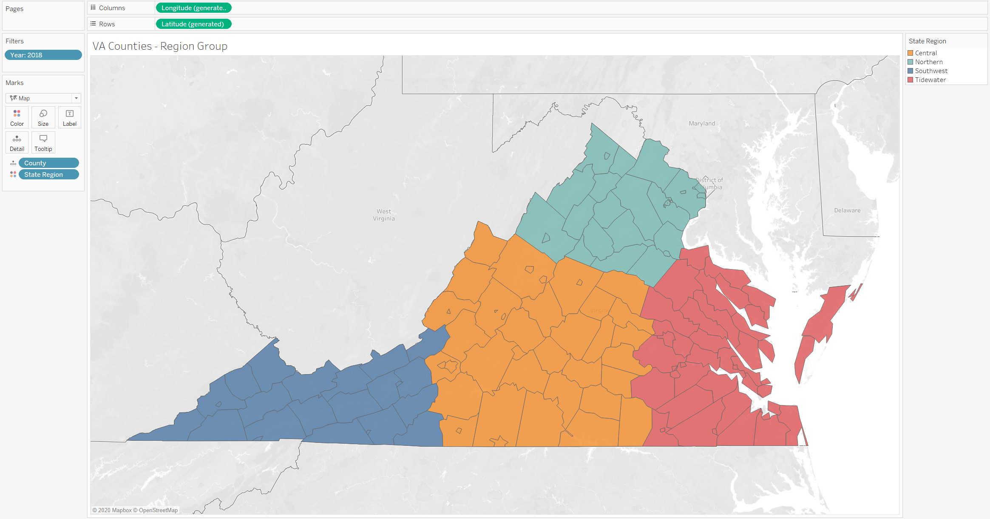

**Step 2 – This creates the Region Map used later in the Dashboard**

1. Duplicate the worksheet “Create Groups” – call new worksheet “Virginia Regions”
2. Uncolor counties
3. Pull counties from detail
4. Drag State Region to map
5. Rename the Group
   1. Select Edit Group – pulldown from State Region
6. Label each Region – format using large Font
7. Rename the Worksheet to “State Regions”

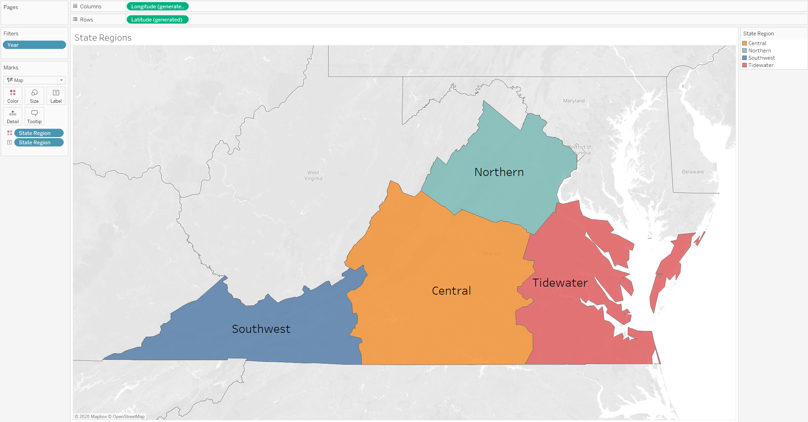

**Step 3 – This creates the density area graph by Region**

1. Start a new worksheet
2. Drag State Region, County to Columns
3. Drag Sum(Density) to Rows
4. Color by State Region
5. Sort by Density
6. Filter on Year
7. Save as Density by Region

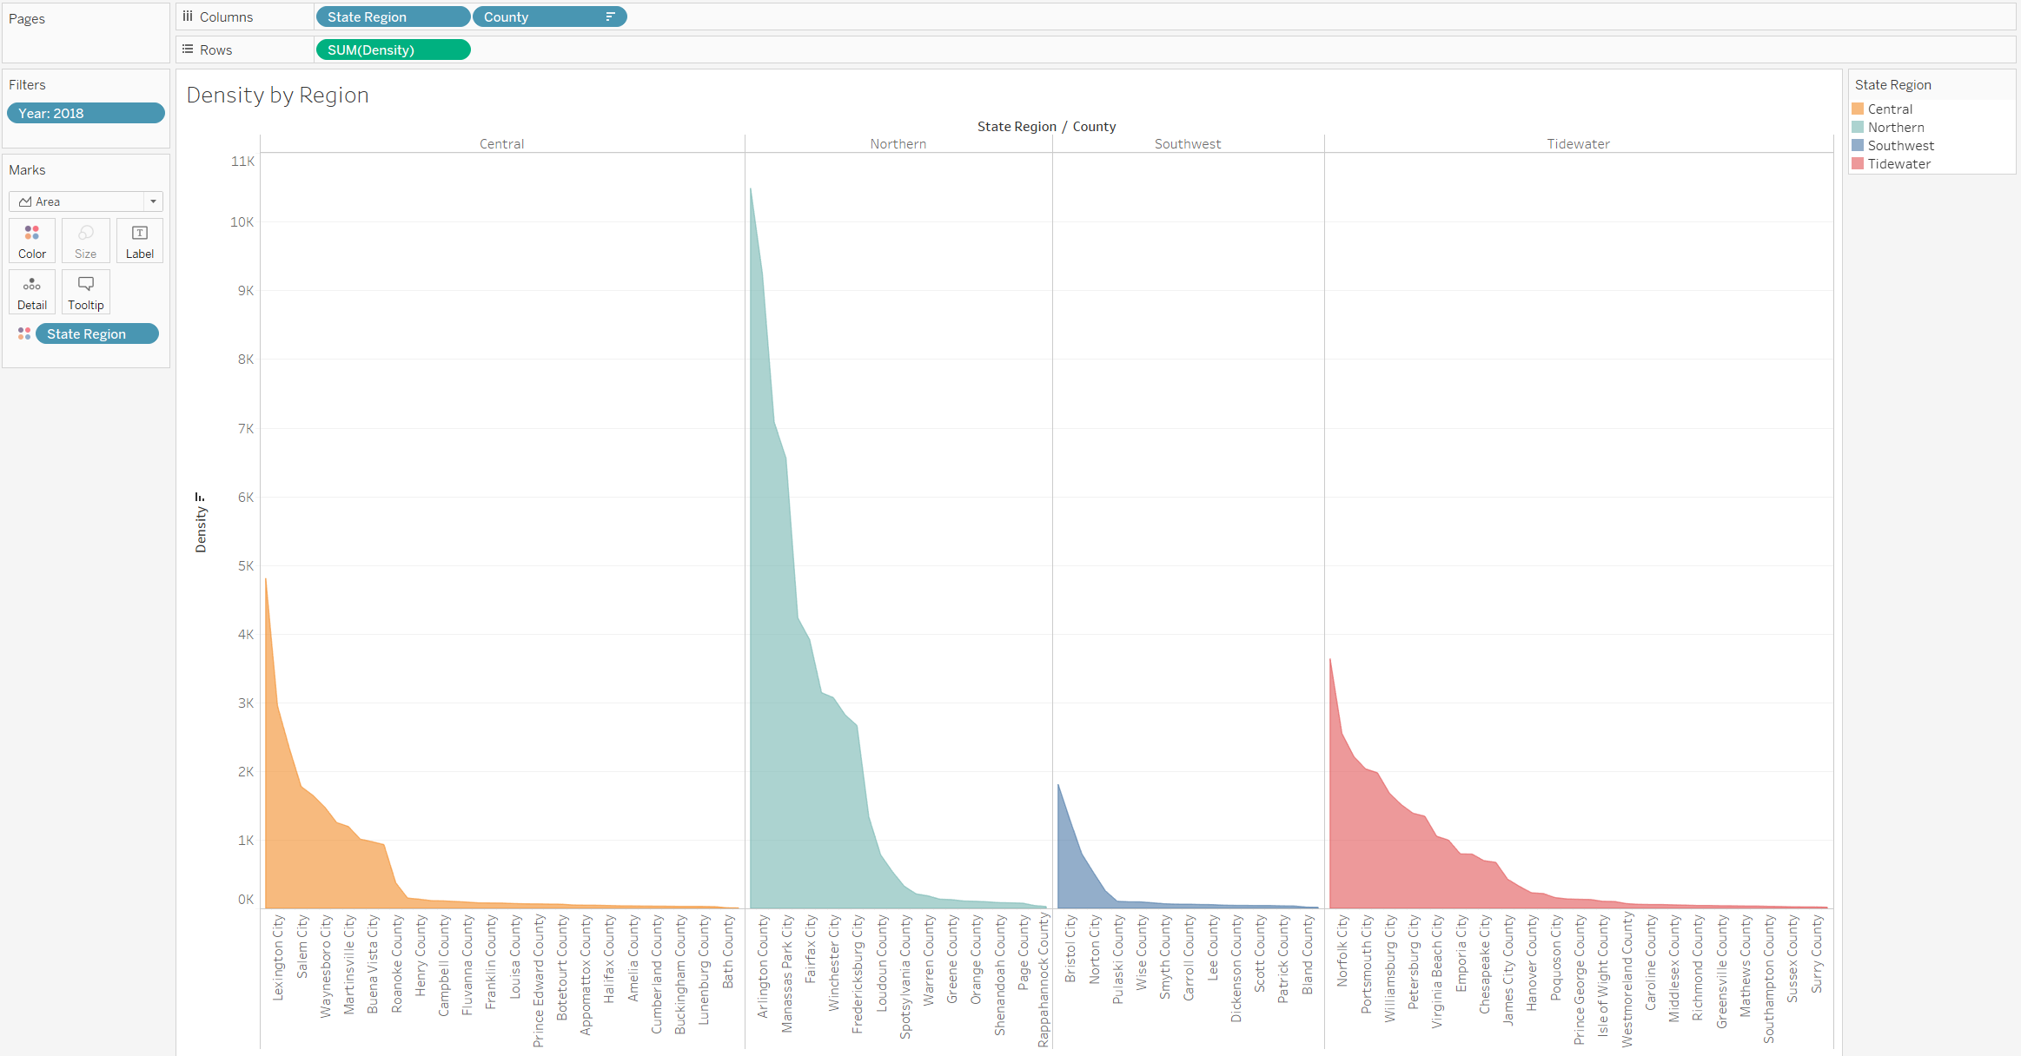

**Step 4 – Now demonstrate the Pages feature**

1. Drag Year Filter to Pages
2. Show options on control for playback
3. Duplicate and rename tagging with Animation

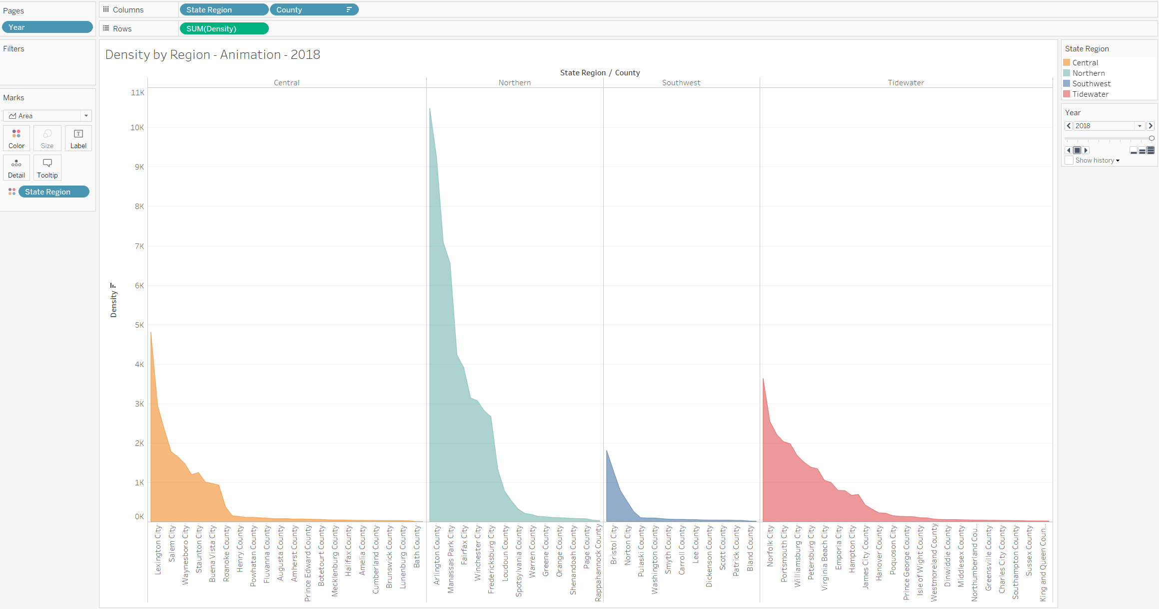

**Step 5 – Build area chart across years on density percentage increase**

1. Demonstrate principle via a crosstab
2. Start a new worksheet
3. Use a table calculation to take a % from base year (2010)
4. Demonstrate table calculation
   1. Year on Columns
   2. Counties on Rows
   3. Density in each cell
   4. Define quick calculation % change
   5. Modify to take across rows relative to first year
   6. Key: Now copy the definition as a new measure [Density Growth]
   7. Create new sheet
   8. Drag Year to Columns
   9. Drag [Density Growth] to Rows
   10. Change to Area Chart

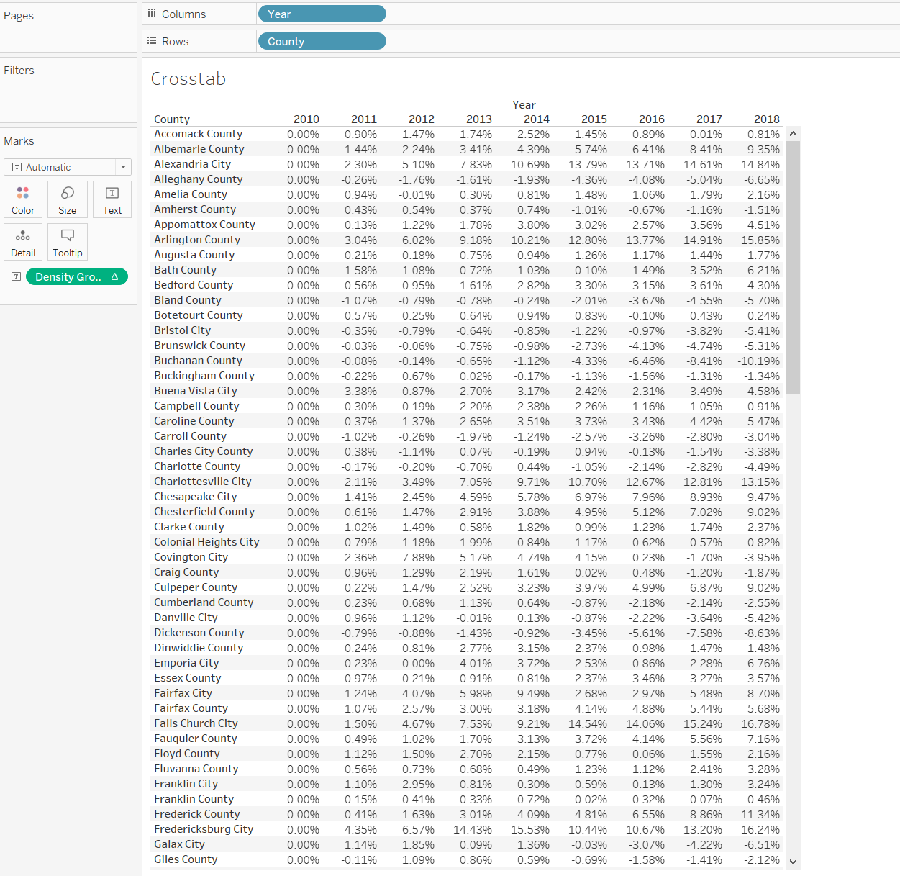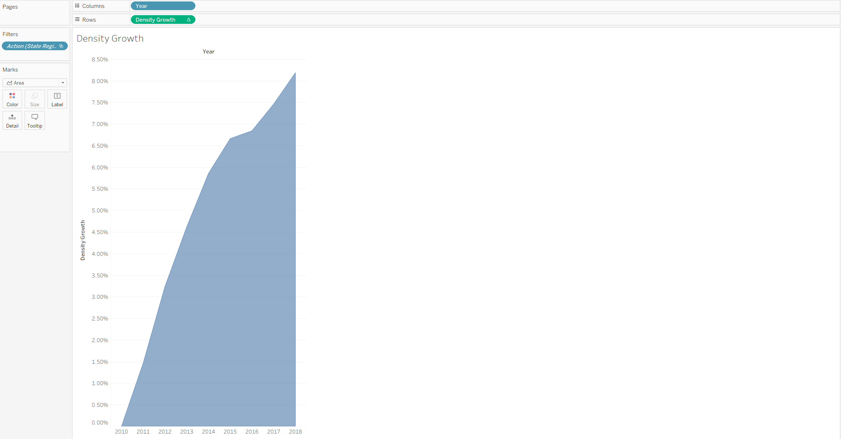

**Step 6 – Define Parameter and Set “Top N Counties”**

1. Define Parameter (Integer, Range, Min=1, Max=133, Show Control, Change to Slider)
2. Define Dynamic Set – Top N Counties – Use Parameter just defined (on County dropdown, Create->Set)
   1. Explain General, Condition or Top
   2. Top(Top <*Parameter>*, Density Sum)
3. Demonstrate its usage by creating a new worksheet – call it Density by Region w/Parameter
   1. Set Filter to Year: 2018
4. Show the parameter control on the new worksheet
5. Replace County on Columns with the Set
6. Modify Set pill from IN/OUT to Show Members
7. Sort by density
8. Test the control

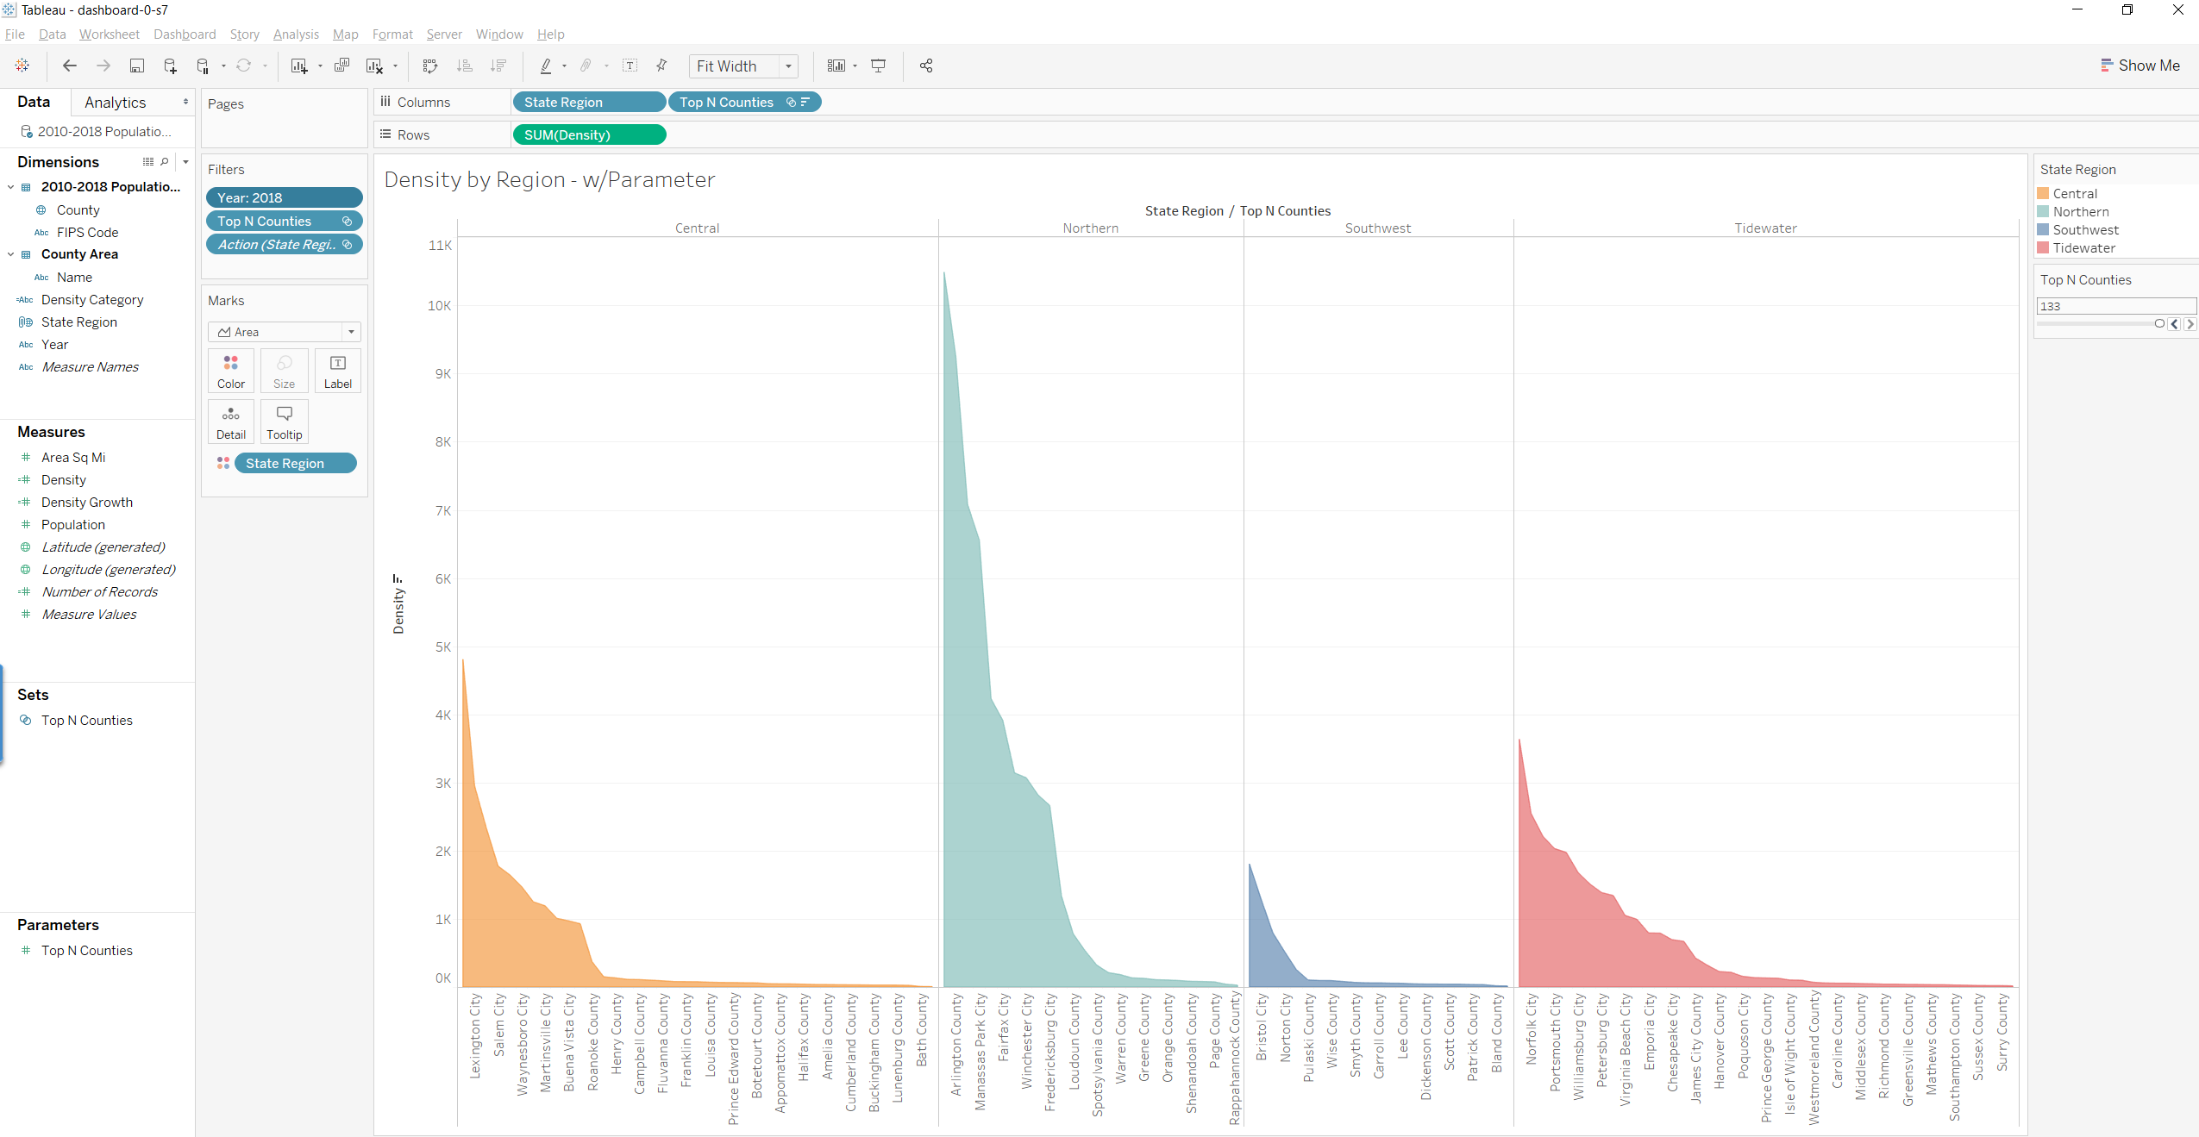

**Step 7 – Build the Dashboard**

1. Create a Dashboard
2. Set Size to Automatic (this will resize your Dashboard to available space)
3. Leave Tiled Set
4. Add State Region, Virginia Counties Density, Density by Region w/Parameter and Density Growth
5. Demonstrate lack of any interaction
6. Set the Region Map to Filter

